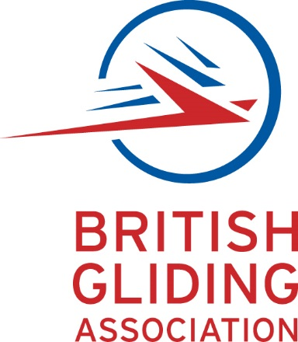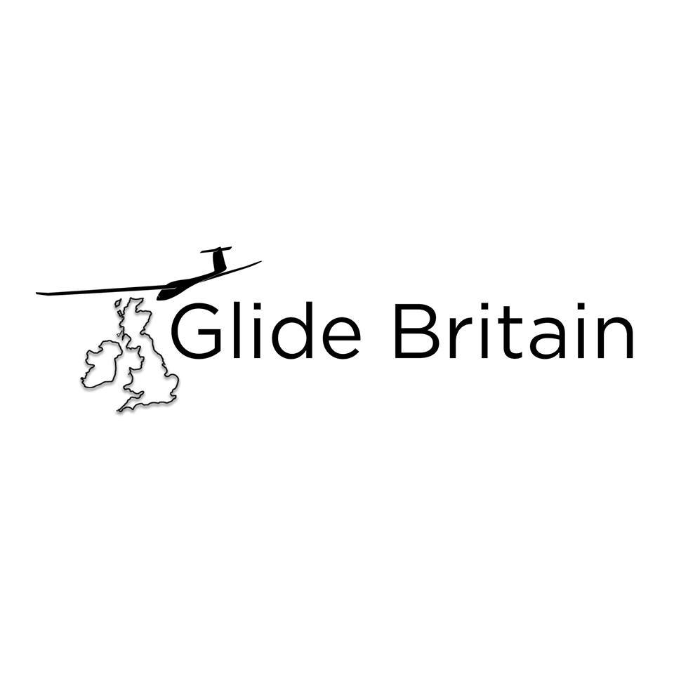

***Press Release***

Glide Britain is a project to raise the general awareness and understanding of gliding among the public at large and thus raise level of participation in this exciting sport.

To do this we're going to be flying a glider on over a 1200 km journey across the UK, visiting 13 gliding clubs over a 2 week period starting on 15th July 2017.

We'll be posting videos, photos & interviews as we go and will be sharing stories of what makes gliding great. We will be looking to our supporters to share these posts with their network to extend the viewing population beyond those currently involved in gliding.

In addition, the glider will be accompanied by a professional film crew with the objectives of producing:

* a broadcast quality documentary of the gliding tour of these clubs.
* a series of videos for use by the gliding community introducing all aspects of gliding including the different launch methods, types of lift, vintage gliding, aerobatics and cross country flying.
* a series of videos introducing the participating gliding clubs

The gliding community knows that the public has little idea of what gliding is all about.  We can fly large distances, flights of more than 300 miles are common in the UK and the distance record exceeds 600 miles.  Gliders regularly achieve heights of 10,000 feet and the UK height record is a staggering 37,000 feet.  We can do aerobatics, we fly very modern gliders but also vintage ones.  We have a very active junior sector, you can fly a glider solo at the age of just 14.

We have four clear messages: gliding is

* safe
* affordable
* accessible
  + no gender issue
  + you can fly solo at 14
  + gliders can be adapted for those with physical disabilities
* fun

The project is financed in a very innovative way with funds from the British Gliding Association, the 13 clubs participating in the project and also from commercial sponsors and from the gliding community using crowd funding.  Over £30,000 has been raised in total.

Follow us on <https://www.facebook.com/glidebritain>

For further information on Glide Britain contact [dave.latimer@blueyonder.co.uk](mailto:dave.latimer@blueyonder.co.uk)

**The Glider**

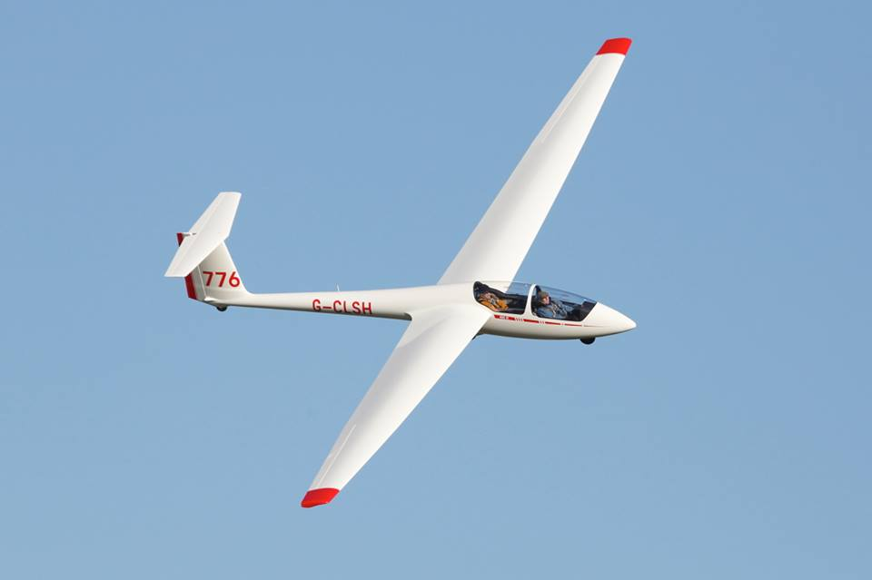

The ASK 21 is a two-seater mid-wing with 17m span, designed by Rudolf Kaiser.  It is widely used in gliding clubs for basic to advanced instruction.  h[ttps://www.alexander-schleicher.de/en/flugzeuge/ask-21/](https://www.alexander-schleicher.de/en/flugzeuge/ask-21/)

**The Route and Timetable**

|  |  |  |  |  |
| --- | --- | --- | --- | --- |
| **Order** | **Club** | **Site** | **Date** | **Day** |
| **1** | **Rattlesden** | **Rattlesden Airfield** | **14.07** | **Fri** |
| **2** | **Cambridge** | **Gransden Lodge airfield** | **15.07** | **Sat** |
| **3** | **Oxford** | **Weston-on-the-Green Airfield** | **16.07** | **Sun** |
| **4** | **Lasham** | **Lasham Airfield** | **17.07** | **Mon** |
| **5** | **Mendip** | **Halesland** | **18.07** | **Tue** |
| **6** | **Cotswold** | **Aston Down Airfield** | **19.07** | **Wed** |
| **7** | **Midland** | **The Long Mynd** | **20.07** | **Thu** |
|  | **REST DAY at Midland** |  | **21.07** | **Fri** |
| **8** | **Herefordshire** | **Shobdon Airfield** | **22.07** | **Sat** |
| **9** | **Denbigh** | **Denbigh Airfield** | **23.07** | **Sun** |
| **10** | **Buckminster** | **Saltby Airfield** | **24.07** | **Mon** |
| **11** | **Burn** | **Burn Airfield** | **25.07** | **Tue** |
| **12** | **Yorkshire** | **Sutton Bank** | **26.07** | **Wed** |
|  | **REST DAY** | **Sutton Bank** | **27.07** | **Thu** |
| **13** | **York** | **Rufforth Airfield** | **28.07** | **Fri** |
| **14** | **Trent Valley** | **Kirton-in Lindsey Airfield** | **29.07** | **Sat** |
|  | **Rattlesden** | **Rattlesden Airfield** | **30.07** | **Sun** |

**About**

**The British Gliding Association**

The British Gliding Association is the governing body for the sport of gliding in the UK. Our members are the 80+ clubs that provide gliding facilities for their members – clubs that are spread throughout the UK from the north of Scotland to the SW tip of England and which range from small, member-run clubs through to some of the largest gliding clubs in the world. Through these clubs we represent and provide services to some 8500 UK glider pilots.  For more information see[**https://www.gliding.co.uk**](https://www.gliding.co.uk)

**Kickstarter Funding**

The Glide Britain team decide to crowdfund a proportion of the project’s required budget using Kickstarter.  We chose to do this to enhance engagement with the gliding community.  The funding has been a great success in terms of raising money, we raised our target twice!  More importantly we have secured over 150 backers who are taking an active interest in supporting the project with their help and experience.

<http://kck.st/2se2KO0>

**Glide Britain Team**

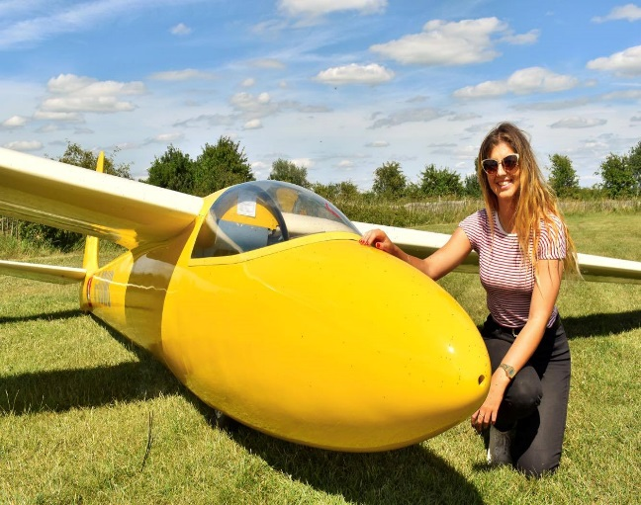**Jago Roberts (20)**

Jago started gliding when she was 15 and recently completed her Bronze Stage and 5 hour endurance flight for her silver Badge. She is an enthusiastic member of Ridgewell Gliding Club and is planning on becoming an airline pilot.  Gliding has been the first flying step in the careers of many of today’s airline pilots.

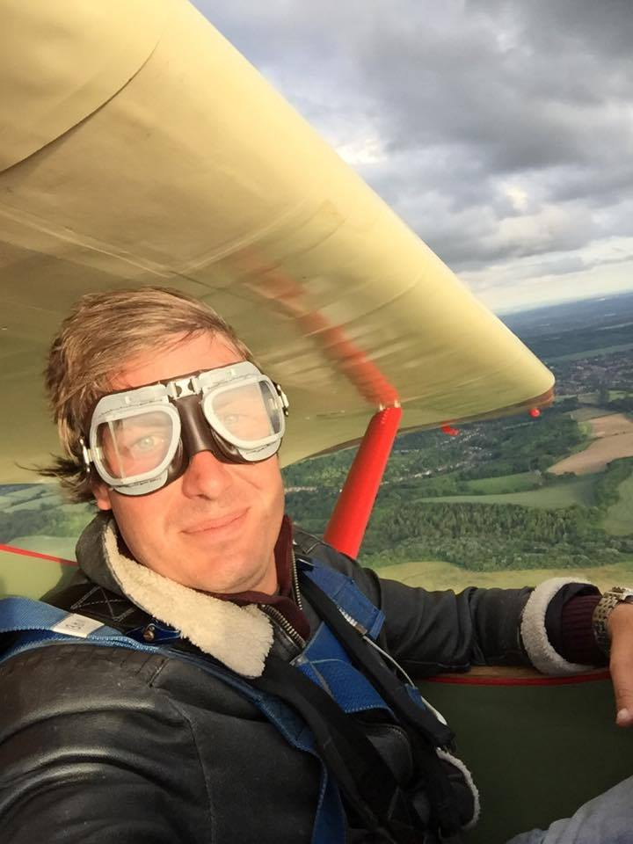

**Alex O’Keefe (30)**

Alex was born into flying, taking to the skies for the first time in a light aircraft with his Father at just a few months old. He has been gliding since he was 11 and is now the Chief Flying Instructor at Rattlesden Gliding Club. Alex is well respected in the gliding community and is an active member of the Junior Gliding movement in the UK.

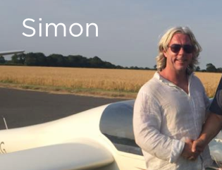

**Simon Grice (47)**

Simon has been gliding for just over 2 years and went solo last summer. He is the marketing secretary at Rattlesden Gliding Club and is the instigator of Glide Britain after realising that gliding as a sport needs much more general awareness.

**Ben Jacobson (43)**

Ben is an award winning independent filmmaker who has been making TV programmes, films (both drama and documentary) and business videos for a range of public and private sector clients for over 20 years. He was an active Air Scout and Air Cadet as a teenager and this project has awoken his love of flying.

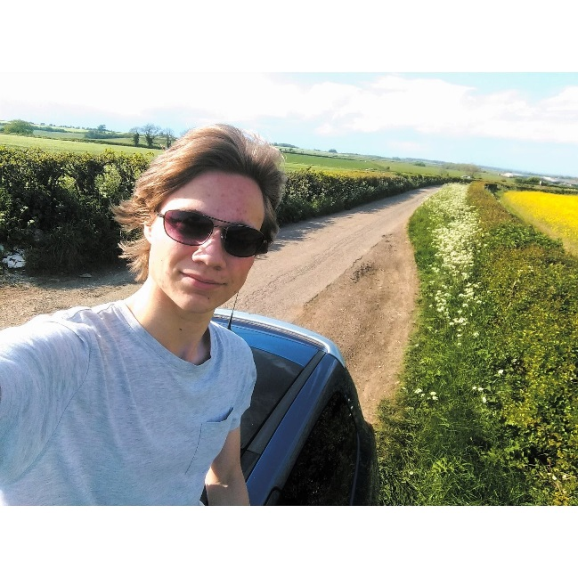

**Dorian Bury (19)**

Dorian started flying at 15. He is the first of his family to fly and currently holds a bronze, cross country endorsement and basic aerobatics badge. Apart from flying he is also an aspiring filmmaker and made a video for Junior Gliding earlier this year

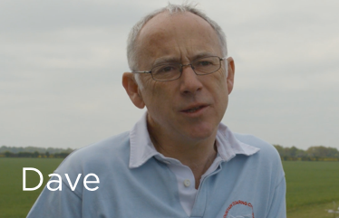

**Dave Latimer (55)**

Dave is a member of the BGA Exec and Chairman of the BGA Development Committee has been organising the project with Simon.  He has been gliding since 1978 and currently flies from the Yorkshire Gliding Club at Sutton Bank.

**The Sponsors**

**Sydney Charles Aviation Insurance Brokers**

Founded in 2006, Sydney Charles Aviation Insurance Brokers Limited has gained an enviable reputation for providing tailored insurance for all types of general aviation needs, from commercial fleets to gliders, gyros and more.

We understand that glider and sailplane insurance can be an unexpectedly complex process. However, with our expertise and knowledge, we are able to make the process as easy as possible and can offer excellent policies and bespoke services.   <http://www.sydneycharles.co.uk>

**Philip Will Memorial Fund**

The PWMF encourages “the promotion of sporting & recreational flying in gliders”, achieved largely by making loans to Clubs at favourable rates to help them with capital projects such as the purchase of land or equipment.

**Lasham Gliding Society**

Lasham Gliding Society in Hampshire is one of the world's largest gliding clubs and provides professionally-run facilities seven days a week for all pilots, from beginners to world champions.

**North Yorkshire Sailplanes**

North Yorkshire Sailplanes was founded in 1992 by Derek Taylor and is more commonly known as NYS.  NYS offers services in composite gliders and motorgliders ranging from Annual and ARC renewals to complex repairs in Carbon Kevlar and GRP structures. Other services include AD ( air directive ) inspections and modification installations, instrument panel design and build, engine maintenance and overhaul.  dereknysailplanes@onebillinternet.co.uk

**London Gliding Club**

Our airfield is situated at the foot of the beautiful Dunstable Downs. We fly 7 days a week (weather permitting!) and offer excellent resources including a large fleet of gliders and tugs, and other facilities including our historic clubhouse. We are proud of our friendly atmosphere, and we provide enthusiastic support all levels of gliding from beginner to advanced cross-country soaring, aerobatics and vintage glider flying. We run a successful cadet scheme.

For more information visit [http://www.londonglidingclub.co.uk](http://www.londonglidingclub.co.uk/)

**Stemme**

STEMME UK LTD is the UK distributor for the German company STEMME AG. STEMME UK sell the high performance STEMME S10 and new S12 touring motor gliders as well as provide support, maintenance and parts to existing STEMME owners in the UK. We are pleased to support the GLIDE BRITAIN initiative and hope for future success in the further development of the gliding community in Britain. [Www.stemme.com](http://www.stemme.com/)

**EuroFOX Aviation UK**

EuroFOX Aviation UK are the UK Agents for the Aeropro EuroFOX.  The EuroFOX has been effectively used for low cost glider towing for over 10 years. Introduced to the UK in 2011, with currently over 20 examples providing 2000” tows for less than 3 litres of mogas per tow. A new 120+ HP EuroFOX tug is due summer 2017.

EuroFOX will be joining the team for a day and following the tour glider.