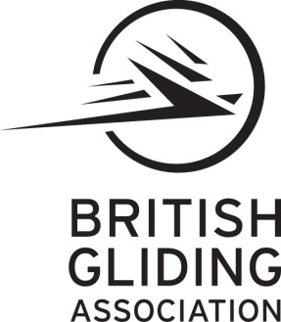

Approval UK.MG.0279

# BGA GMP

**Sailplane and Self Sustaining Sailplane Maintenance Programme**

# Ref: BGA/GMP/2005 issue 1 revision 2

**Aircraft Type:****Registration:**

**BGA Number:****Serial Number:**

**Engine Type** **Propeller Type**

**Owner’s Name**

**Owner’s Address**

**British Gliding Association Ltd,**

**8 Merus Court, Meridian Business Park, Leicester. LE19 1RJ.**