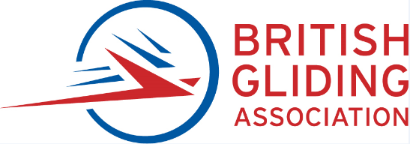
Application for Issue or Extension of a

BGA Inspector Maintenance Authorisation
V1.2 (see relevant AMP for details)
BGA Inspector Number
I/ /
Title: | First Name: | Second Name and Initials:
Surname: |  | Date of Birth (dd/mm/yyyy):
Home address:

Postcode:
Email address: |  | Telephone:  Mobile
Your home BGA club:

Is this an initial issue or an extension to existing Authorisation
BGA Inspector Ratings – full details in BGA Airworthiness Exposition Tick relevant box(s)
GL |  | Glider Inspector (AF) | WR |  | Wooden Airframe Repair
MR |  | Metal Airframe Repair | CR |  | Composite Airframe Repair
SS |  | Self-Sustainer Sailplane Engine | MG |  | Powered Sailplane & Motor Glider
TG |  | Tug Inspector | ST |  | Senior Tug Inspector
EP |  | Electric Powerplant | RE |  | Radio Engineer
CE |  | Chief Engineer/ARC signatory | JP |  | Jet Powerplant
CM |  | Component Maintenance | EO |  | Engine Inspection and Repair
DU |  | Duplicate Inspections Only | S |  | Senior Inspector

Employer and/or profession:

Training and Qualifications applicable to ratings applied for:

Please bring applicable certificates to interview.
Please see additional information required for new applicants.
General experience
From To | Name of company, club etc and type of work demonstrating a minimum of four years in applicable maintenance or continued airworthiness: | Confirmed by
Please attach worksheets detailing work experience for the ratings applied for.

BGA 220 Personal Experience Record (PER) may be used or other suitable format.

Additional information required by new applicants (Biographical Data)
Basic training (Vocational training, Further education etc):

Type and specialised training (Specific to aircraft maintenance and continued airworthiness):

Recurrent training (Inspector seminars, continuation training, Human Factors training):

Nominations – initial applications. By signing below, I confirm the following:
I consider the applicant to have sufficient technical knowledge, skills and applicable work experience to be granted a BGA Inspector authorisation. I have reviewed the work experience details submitted to support this application.
I also consider the applicant to be suitable in all other respects to be a BGA Authorised inspector.

Note - at least one signatory must be a current BGA inspector.
Name____________________________________________ BGA Authorisation No____________________

Signature_________________________________________Date__________________________________
Name____________________________________________ BGA Authorisation No____________________(if applicable)

Signature_________________________________________Date__________________________________

All applicants:
Other supporting information:

Venues for interview – Leicester preferred or elsewhere by arrangement.
Interview Location:

Please note: during the interview you will be required to show a photographic form of identity (driving licence or passport).
Signature of Applicant: | Initials: | Date:
BGA Use Only
Interview completed by__________________________________________________Date__________________

CTO use only:

Authorisation / ratings approved___________________________________________________________

Signed ______________________________Date_________

Please send the completed form to:
British Gliding Association, 8 Merus Court, Meridian Business Park, Leicester, LE19 1RJ

Please do not send any fees at this stage.

