9a – SLOW FLIGHT

INTRODUCTION

Even though stalling is in itself a benign flight condition, it is still a major contributory factor in gliding accidents, not because the pilots involved didn't know the correct recovery action, but because they didn't recognise what was happening. This is why the training must strongly emphasise recognition of, and familiarity with, the symptoms of the stall.

Slow Flight, whilst not strictly speaking a stalling exercise, is an important part of stall recognition and hence avoidance. In addition to stalling exercises it should be practiced pre-solo, pre-licence and post licence issue in its own right. In practice it can be repeated as part of the Un-accelerated stalling exercises in Chapter 9b. Indeed there is considerable overlap of exercises 9a and 9b. This may be perceived as a trivial exercise and when conducted correctly is unspectacular, but do not skimp time on this exercise, it is valuable accident prevention.

The table below indicates the aspects of Slow Speed Flight specified for SPL Training:

|  |  |
| --- | --- |
| **Exercise 9a: Slow Speed Flight** | |
| (i) | Safety checks |
| (ii) | Introduction to characteristics of slow flight |
| (iii) | Controlled flight down to critically high angle of attack (slow air speed) |

**Note:** The objective is to develop the trainee’s ability to recognise inadvertent flight at critically low speeds (high angle of attack) and to provide practice in maintaining the sailplane in a normal attitude at low speed.

This exercise and stalls should be practised often, enough to ensure that the trainee’s habitual response to slow flight is to move the stick forward. However, formal stall training should only be introduced when the trainee is familiar with the sensations of flying and reasonably confident of their ability to control the glider. Beware of doing stalls with markedly reduced G before you have determined whether the trainee is sensitive to it or not. Care needs to be taken not to accidentally stall whilst conducting this exercise, or worse, to allow the trainee to stall accidentally before having been familiarised with stalling.

Training Content

The aim of this exercise is to establish an automatic link in the trainee between the feel of the glider and slow flight so that they are aware of impending stalls.

Trainees are often very apprehensive about stalling, so use these slow flying exercises and a very gentle 'confidence stall' before introducing this or the stall exercises in Chapter 9b. It is vital that everything possible be done to make the stalling exercises a positive learning experience. Some trainees are uncomfortable with the idea of stalling and unfortunately if they are concerned, then they won’t be learning.

When introducing slow flying, make it clear that the exercise is to help the trainee recognise the feel of the glider and control response rates near the stall; not to develop skill in 'slow flying'.

Slow flying training is a continuing exercise, both pre- and post-solo. The aim is for the trainee to:

* recognise the symptoms of an approaching stall and take timely avoiding action.
* avoid inadvertent stalling by developing safe flying habits in all phases of flight.

### Miscellaneous

As modern gliders approach the stall any variations in airflow noise may be very subtle, but the fact that they can occur should be mentioned.

It is important that even if an overzealous trainee moves the stick fully forward, you can still reach it. Reduced G combined with loose straps might leave you unable to take control.

The Exercise

The exercise consists of flying just above the 1 G stalling speed. (@ 2 kts.) In the region where the aircrafts handling is beginning to change from that at normal speeds, but not actually yet stalled. Every trainee must repeatedly fly these exercises until completely familiar with this regime of flight.

The objective of this exercises is to train pilots to **recognise and avoid stalling.** The trainee needs to experience the response and feel of the controls at this crucial point – this is knowledge which might one day save their life. The exercise should be introduced as soon as the trainee develops sufficient coordination to use all three controls together whilst maintaining a heading.

THEORY BRIEFING

AoA and the stall

* In normal flight a glider’s wings must produce a lifting force near enough equal to the glider's flying weight. The amount of lift generated depends on the aerofoil (overall shape), wing area, and the speed and angle at which the airflow meets the wing. The angle is called the **Angle of Attack**, or AoA for short (figure 1), and is measured between the aerofoil **chord line** and the **relative airflow**.
* If the glider is in steady, fast straight flight, the AoA will be small, but becomes progressively larger as the glider slows down, or as G increases. There is a **critical**

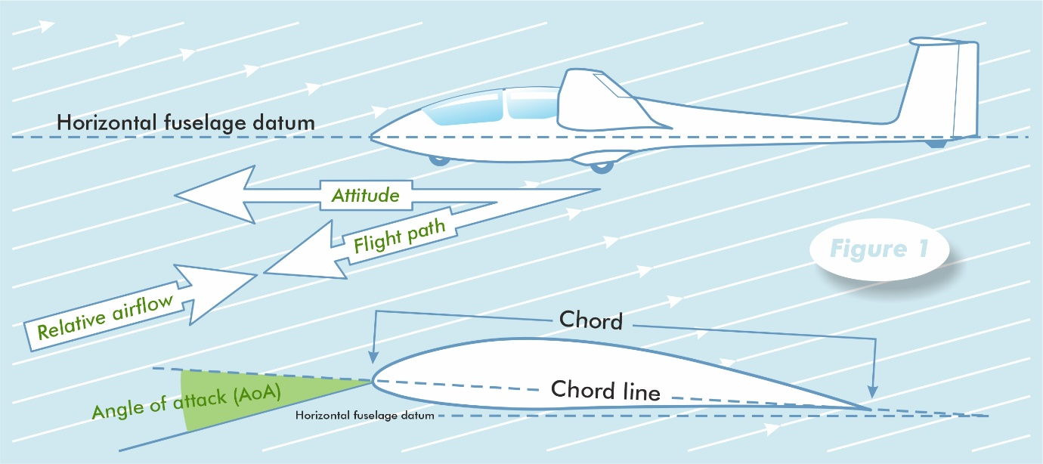

**angle** for the AoA - aerofoil specific, but typically about 15° - where the lift coefficient, or CL reaches a maximum. If the AoA is increased further, lift will reduce, sometimes quite sharply, but the drag will continue to rise. Technically, the stall is defined as occurring when the CL has reached its highest possible value, regardless of anything the glider is doing at the time.

* Explain that changes occur in the handling and feel of the glider when indulging in Slow Flight at high angle of attack close to the stall and that these can provide useful warning of an impending stall.

Further points

* Flying the glider close to the stall is inefficient, and - excluding the float just before touch-down - dangerous if close to the ground.
* The wings of most gliders are designed to stall in a smooth and progressive manner, either through using a different aerofoil section near the tip, or building in ‘washout’ or both. Airflow breakdown begins at the upper surface trailing edge, near the wing root, and spreads forwards and outwards as the AoA increases.
* The above features enable many gliders to maintain some aileron control, however minimal, at, and sometimes just beyond the stall. In general, though, as more of the wing stalls, the ailerons become increasingly sluggish and ineffective.
* Secondary effects of rudder inputs at, or just prior to the stall can have much the same effect, except that the glider may roll strongly in the direction of the rudder input.
* Depending on the glider’s elevator authority and/or the rate at which the speed is reduced, the elevator may fail to raise the nose in response to backward movement of the stick, or the nose may drop regardless. **Inability of the elevator to raise the nose or prevent it going down is the most important symptom of a stall.**
* As the glider slows down there may be a perceptible change in the airflow noise. While usually quieter, it can also be louder or different in character, and may sound completely different if there is any significant yaw present.
* Separated airflow can produce airframe buffet, and turbulent flow across the static ports can cause the ASI readings to flicker. However, this will only be experienced if the glider is flown at the stalling speed rather than just above it as intended in this exercise.

### Summary of Slow Flight symptoms

Not all of the following may be present, or all that obvious:

* the nose higher than normal
* the airspeed will be slow
* changes in airflow noise
* changed effectiveness of elevator, ailerons and/or rudder
* unusual control positions for the phase of flight. For example, lots of out-turn aileron or stick further back than usual

AIR EXERCISE BRIEFINGS

Before flying this exercise include Threat & Error Management, along the lines of the example below, and the HASSELL check [Section 1 - e] in all of the pre-flight briefings.

|  |  |  |  |
| --- | --- | --- | --- |
| **TEM** | |  | |
| **Threats:** | | **Mitigation:** | |
|  | Trainee Adverse Reaction |  | Prepare and brief the trainee appropriately & monitor them carefully |
|  | Trainee fails to or over reacts at recovery |  | Monitor trainee & take over promptly |
|  | Collision |  | Maintain thorough Lookout |
| **Errors:** | |  |  |
|  | Running out of height for appropriate circuit |  | Monitor height & position |
|  | Allowing a stall to develop |  | Be prepared to recover immediately if a stall appears imminent |

### Slow Flying

If the pilot either fails to notice or ignores the symptoms, when the glider is flown too slowly:

* an inadvertent stall may result

To recover, the AoA MUST be reduced:

* ease forward on the stick to lower the nose at least to the normal gliding attitude
* regain normal flying speed
* return to the required gliding attitude (for that phase of flight).

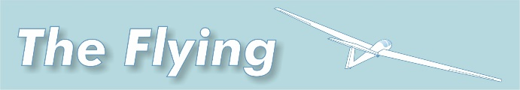

SLOW FLYING DEMONSTRATION

**Initially, ask the trainee to keep their hands and feet off the controls. Only invite them to follow through once he/she knows what to expect (i.e., you have demonstrated it, perhaps several times) and you are reasonably sure that they won't react badly.** Given the significant risk of accidentally stalling whilst conducting this exercise the trainee should be shown a gentle introductory stall ahead of this exercise. This advice is relevant to all stalling exercises.

**SLOW FLYING**

Demonstrate Slow Flying and introduce the symptoms of this flight regime. The first demonstration should be followed by several more, each concentrating the trainee’s attention on the one of the symptoms of slow flight, but a recovery should be made before the stall.

Slow Flying

* complete the HASSELL check (some of it can be done prior to take-off).
* bring the nose slightly above the normal flying attitude.
* identify the symptoms of slow flight as they occur.
* note the airspeed.
* stabilise the glider in this attitude.
* emphasise that this is the Slow Flying and is very close to the stall.
* demonstrate the recovery action.

Emphasise that:

* because the glider is being flown too slowly that it is essential to move the stick forward to recover.
* that flying too slowly is both inefficient and potentially dangerous.

SLOW FLYING LESSON

**TRAINEE ATTEMPTS AT SLOW FLYING**

The aim is for the trainee to fly just above the 1G stall speed and to:

* identify the symptoms of slow flight
* recognise the impending stall

## Slow flying exercise

The primary aim is to give the trainee prolonged experience of the feel of the controls when the glider is too/very close to the stall.

* complete the HASSELL check.
* the trainee reduces speed very gradually (approximately 1kt/sec) towards the stall. The aim is to try and fly the glider just above the stall (@2 kts) while keeping the wings level with coordinated controls.

Emphasise;

* the change in feel of all of the controls.
* that the stick is further back than for normal flying speed, even though the glider’s attitude is not dissimilar to ‘normal’.

Recover.

DE-BRIEFING

Review the symptoms of the approaching stall encountered in this exercise. Emphasise that only one symptom needs to be recognised for stall avoidance or recovery to be initiated.

Discuss the many different situations where excessively slow flight may lead to a stall and emphasise the need to move the stick forward to recover.

Having completed this exercise brief the trainee to avoid slow flight unless a specific exercise requires it and to recover without prompting when they recognise symptoms of slow flight.

COMMON DIFFICULTIES

**H**ASSELL check. Uncertainty about how much of the HASSELL check is required and the appropriate areas of lookout. These depend on the exact nature of the exercise, and the degree of certainty about the outcome (ie., height likely to be lost). Whilst stalling may not be planned, it may occur accidentally whilst slow flying.

**F**ailure to maintain the glider in the narrow band qualifying as ‘Slow Flight’. This may occur if the trainees handling is as yet insufficiently developed.

**A**ccidentally stalling the glider by failing to maintain the glider in the narrow band qualifying as ‘Slow Flight’. This may occur if the trainees handling is as yet insufficiently developed.