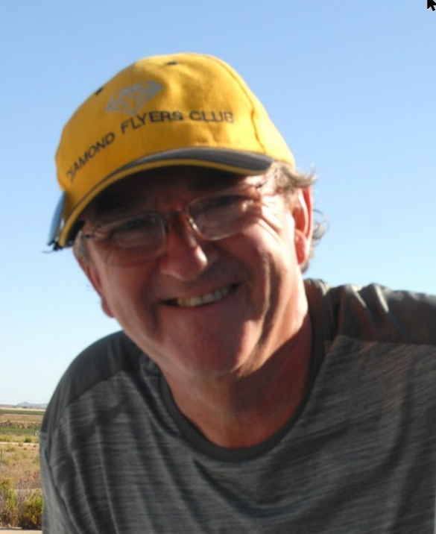**Alan Baker – GB Team Captain**

**Flies**: Pipistrel Taurus

Alan started gliding in 1974 at Bicester since accumulating 4500 hours flight time and also holds an Arline Transport Licence with a similar 4500 hours in powered aircraft and still enjoys instructing on both.

After his time as an aeronautical engineer (Harriers and Puma Helicopters), Alan has held business development posts in Aerospace, Large Computer Solutions (ERP) and Weather Data (inventing a briefing service for the world’s airlines).

He now holds a passion for sustainability, electrification and leaving kids some fresh air to breath.

**Hobbies:**

Alan is never far away from a guitar or the sun, particularly viewed from Spain, likes live music, modern jive dance and generally making the world a better place. Not to forget helping gliders go faster, safely!