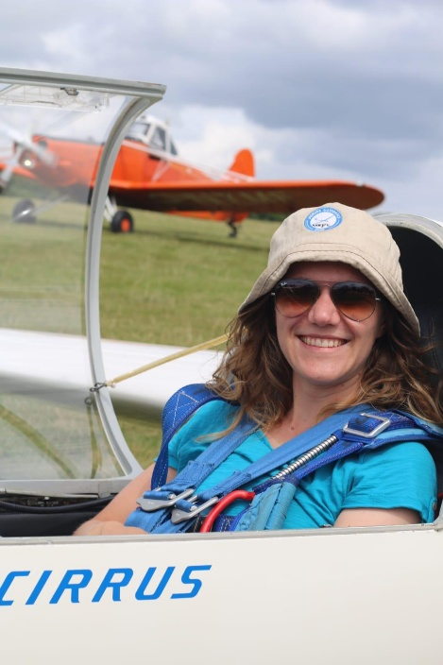**Anne Soltow**

**WWGC Team GB – Club Class**

**Flies:** Standard Cirrus

**Home Club**: Bristol & Gloucestershire Gliding Club

Anne first learned about gliding when she joined Imperial College London to study Aeronautical Engineering in 2017 and heard her classmate talk about their gliding adventures. She finally decided to give it a go at Lasham and was hooked after a university gliding club trip to Issoudun when she was 21.

Immediately after completing her silver distance in 2021, she knew that she wanted to become a competition pilot. Since then, she has developed her gliding and powered flying skills, competed in various competitions in the UK and became a gliding instructor.

Now, at 27, she works as a software engineer at an aerospace company and spends most of her weekends at Bristol and Gloucestershire Gliding Club.

She is eager to take part in her first international competition in the club class flying a Standard Cirrus she is kindly loaned, alongside her experienced teammate, Jane Nash.