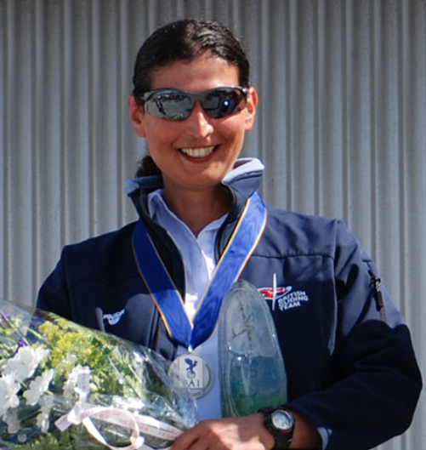**Ayala Truelove**

**WWGC Team GB – 18m Class**

**Flies:** JS3

**Home Club:** Lasham Gliding Society

Ayala started gliding in 2001 hoping that flying in a glider would help her overcome her fear of flying… After that first safe landing she joined Reading University Soaring Society at Shalbourne Gliding Club, went solo in 2002 and got her Silver a year later.

Her passion is cross-country and competition gliding and she flew her first Regionals at Dunstable in 2004 and her first international competition in 2009 where she came 4th in the Club Class in the Women’s World Championships, narrowly missing top spot on the last day.

Ayala won silver medals in the Club Class in both the Sweden 2011 WWGC, and France 2013 WWGC, where she narrowly missed out on gold after leading at the start of the final day. Her best National result to date is winning the UK Standard Class Nationals in 2015.

At the 2020 WWGC in Lake Keepit, Australia, Ayala competed in the Standard class for the first time and won bronze medal after 10 long flying days.

She is an Instructor at Lasham gliding club and when the weather is bad she flies a Cessna 175 aircraft from Brimpton.

Ayala’s other sporting passion is football, and she has played for Charlton and Southampton in the Women’s Premier League and earned 12 International caps playing for Israel.