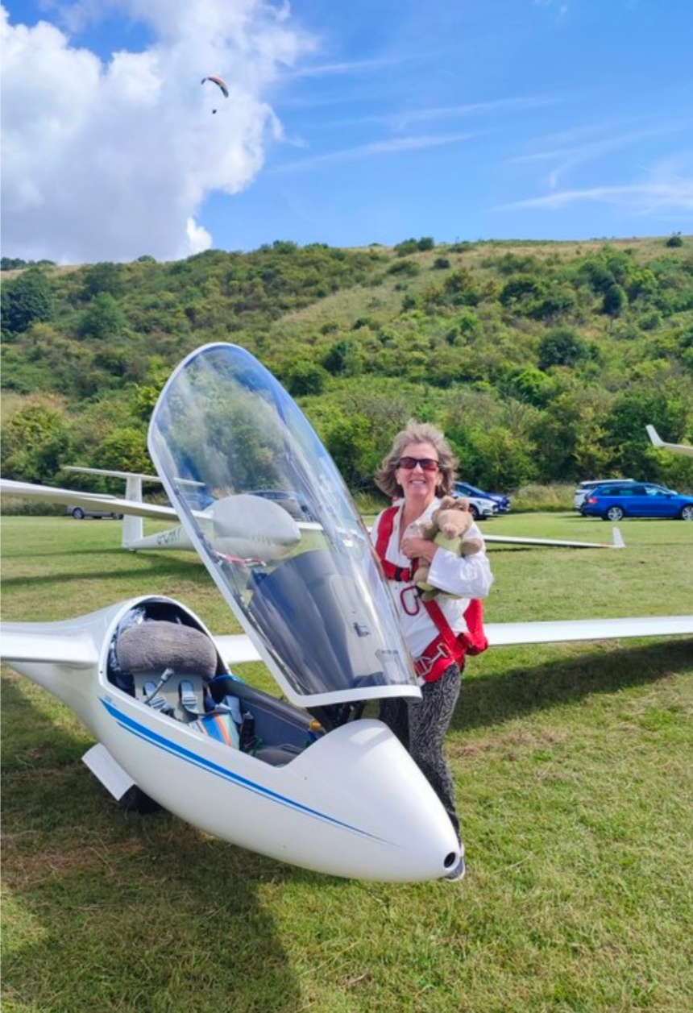

**Jan McCoshim**

**WWGC Team GB – Standard Class**

**Flies**: LS8

**Home Club**: Dunstable

Jan’s aviation journey started at 16 on a weeks gliding course at Portmoak in Scotland, a present from her father for gaining the exam grades to go to veterinary school. She was instantly hooked and therefore chose the vet school at Edinburgh University as it had a gliding club!

Once qualified she gained a PPL and learnt to fly the tow planes at Deeside GC where she had a share in a glider. After 3 years as a vet she decided to change careers and pursue her passion for flying, initially becoming a flying instructor and then after gaining her ATPL a long haul commercial pilot.

Jan joined Booker GC in the nineties and started flying in regional and national competitions. She was a member of the British team at the first WWGC in 2001 in Lithuania.

She now flies a LS8 and both she and her glider are looking forward to returning to fly in the Czech Republic where they last flew in 2003 at the second WWGC at Jihlava.