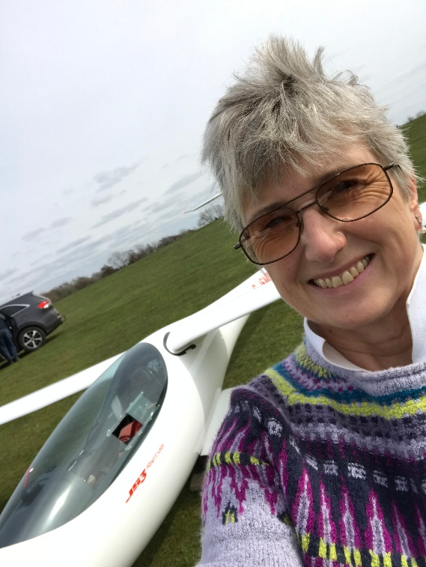**Jane Nash**

**WWGC Team GB – Club Class**

**Flies**: SZD-55-1

**Home Club**: Lasham Gliding Society

Jane started gliding in 1980 and has flown in many Regional and National Competitions.

She first flew the Women’s European Championships at Husbands Bosworth, UK in 1991, and followed this up with the 1993 Women’s European Championships at Hosin, Czech Republic, the 2011 Women’s World Championships in Arboga, Sweden, and the 2022 Women’s World Gliding Championships at Husbands Bosworth, in the UK again, this time flying a loaned JS3 in the 18m Class.

Jane is a Health, Safety and Quality professional and has worked in the Aviation, Healthcare and Oil & Gas industries, and currently ensures the safety and wellbeing of over 700 Engineer Surveyors who carry out statutory inspections across many different types of businesses.

Having spent 42 years as a Fully Categorised Instructor and sending many people solo, Jane has recently retired from instructing in gliders; however she continues to fly in many gliding competitions, and also flies power aircraft (SEP) aerotowing gliders.

In her spare time Jane enjoys singing in a community choir, playing the ukulele and the classical guitar, and giving recitals for charities. She also enjoys gardening, going on long walks with her husband Steve and Celine (a Saluki dog), and looking after her chickens!