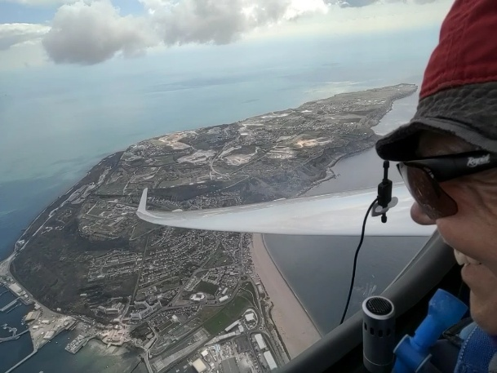**Liz Sparrow**

**WWGC Team GB – 18m Class**

**Flies**: ASG29

**Home Club**:Lasham Gliding Society

Liz started gliding in 1990 and now has around 4000h; she flies her ASG29 from Lasham Gliding and instructs at Shalbourne Soaring Society.

Liz is a founder member of the women pilots’ development initiative Women Gliding, and is Director of the BGA Go Gliding programme which wows young people - especially those from groups currently under-represented in aviation – with the awesomeness of gliding and encourages them to consider STEM careers.

Liz, a regular competitor in Regional and National competitions, made her international debut in 2003 and has qualified for each Women’s Worlds since. She flew in the senior European Championships in Poland in 2013, becoming top ranked woman in world gliding and 80th overall. In 2019, she made the move from Club Class to 18m and fell head-over-heels in love with the extra performance.

Liz didn’t compete in WWGC2022, instead taking on the role of Championship Director for the successful competition held at The Gliding Centre. She was back in the cockpit to compete in Spain in 2023 and is really looking forward to racing in the Czech Republic.

Liz has an engineering degree from Queens’ College, Cambridge University and a Fellowship in Manufacturing Management from Cranfield University. She’s just retired from running a consultancy designing award-winning public services. In the spaces between gliding and looking after a large garden, Liz and husband Alan are keen hikers.